24 April 2026
Doctor R. Berghoff
Quin Barnard, #27902277
Melyssa Seyffert, #28351894
Paige de Canha, #27878163
Alicha la Grange, #28669363
PARSING OF MULTIPLE NEGATIVE INDEFINITES IN DIFFERENT VARIETIES OF AFRIKAANS
General Linguistics 318: Language Processing

Table of Contents
Table of Contents 1
i.) Introduction & Background (Melyssa) 2
ii.) Research Question and Hypothesis (Quin) 4
iii.) Proposed Methodology (Alicha) 4
iii-a.) Participants 4
iii-b.) Materials 5
iii-c.) Procedure 6
iv.) Expected Results and Implications (Paige) 6
v.) Ethical Considerations (Quin) 8
vi.) Statement on AI Use 9
vi-a.) Where any AI tools were used? 9
vi-b.) Why and how were AI tools used? 9
vi-c.) Critical reflection on how our AI use aligns with the guidelines discussed in class and in the readings available on SUNLearn: 9
vii.) Division of Labour 10
viii.) References (Compiled and Checked by Quin) 11
ix.) Appendix 12

i.) Introduction & Background (Melyssa)
Language processing does not occur in a vacuum. The way in which a speaker parses a sentence is influenced both by internalised grammar and the specific social variety they use. Afrikaans serves as a prime example for studying the link between social identity (sociolinguistics) and the mind (psycholinguistics) because of its unique negation system. Focusing specifically on the distinction between prescriptive standard and colloquial Afrikaans, and on their differences regarding multiple negative indefinites (MNI’s), provides deep insights into how sociolinguistic background affects psycholinguistic processing.
In the literature on negation, Afrikaans is classified as a negative concord language, which is a language in which multiple negative elements within a single clause combine to produce a single, unified negative meaning, rather than cancelling each other out to yield a positive, double negation interpretation (Huddlestone & De Swart, 2014). Standard Afrikaans achieves negative concord through a canonical pattern in which a single negative indefinite is paired with one or more non-negative indefinites or negative polarity items. For example, in the sentence ‘Ons het niemand ooit daar gesien nie’, where only one negative word (niemand) is used alongside a non-negative one (ooit). Utterances containing MNI’s are typically prohibited from formal, standard Afrikaans, where a double negation meaning is usually used.
Perception experiments using auditory stimuli indicate native speakers’ judgements of multiple negatives are of gradient acceptability, depending on which specific pairing of negative and non-negative indefinites is used. Critically, experimental data indicate that prosody is essential for disambiguation; for instance, a neutral intonation typically signals a single negation, while a specific rising-falling pitch signals double negation. Huddlestone and De Swart (2014) account for this through the bidirectional Optimality Theory, demonstrating that the interplay between production and interpretation constraints can account for the ambiguity introduced by MNI’s in colloquial Afrikaans.
There is, however, a gap within their treatment of the “colloquial” as a broad, undifferentiated category. This binary contrast fails to capture the true heterogeneity of the language. For example, Kaapse Afrikaans (spoken in the Western Cape) is better understood as a fluid cluster of varieties shaped by specific communities of practice and high levels of intraspeaker variation, a significantly different reality from interior dialects like Transvaal Afrikaans (Seckakaaps, 2019). The sociolinguistic divergence between these varieties is deeply bound up with the political history of language.
The establishment of Afrikaans, which peaked in the late 1800s, was politically motivated and exclusively focused on white Afrikaans varieties. Non-white Afrikaans varieties, such as Arabic-Afrikaans, were entirely excluded from this process (Watson, 2019). The resulting standard language became the language of a white, cultivated elite, used as an instrument of social exclusion against other speakers of Afrikaans, including the working-class communities, people of colour, and speakers with informal education (Johanita, 2021). This resulted in the elite, white Afrikaans becoming the standard form used in schools, universities, and government, while Kaapse Afrikaans was seen as inferior and non-standard. Standard Afrikaans most closely reflects that of Transvaal Afrikaans.
This politically entrenched asymmetry has direct implications for speakers’ linguistic intuitions. If speakers of Transvaal Afrikaans have been more thoroughly exposed to prescriptive norms prohibiting MNI’s, they may be inclined to internalise grammar that is seen as unacceptable or pragmatically marked. Speakers of Kaapse Afrikaans, whose variety has historically operated outside the prescriptive standard, may have different interpretations of negative concords. This constitutes a meaningful and underexplored dimension of the Huddlestone and De Swart (2014) article.
Beyond the Afrikaans context, psycholinguistic research shows that negation processing is not dictated solely by formal grammar; instead, context and structure allow speakers to navigate both negative concord and double negation (Blanchette, Nadeu, Lowder & Kidd, 2015). Suggesting that parsing is shaped by variety exposure and speaker experience rather than just category membership.
This research investigates how speakers of Kaapse Afrikaans and Transvaal Afrikaans differ in their real-time parsing of MNI’s. Emphasis is placed on internal dialectal diversity; this study moves beyond the standard-colloquial binary found in existing literature. This approach provides a more granular understanding of language processing in South Africa, showing how specific sociolinguistic backgrounds influence syntax-semantics interface.

ii.) Research Question and Hypothesis (Quin)
The study will concern itself with a potential gap in an article by Huddlestone and de Swart (2014). They investigate the structure of negation in Afrikaans and a possible structural ambiguity introduced by MNI’s in a single sentence. Reference is made to “colloquial Afrikaans’s” tolerance of MNI’s to convey a negative meaning which is traditionally prohibited in the standard variety of Afrikaans. Afrikaans is, however, not homogenous but rather consisting of many distinct variants that could be described as colloquial (Basson, 2022; Grebe, 2014a). The present study will aim to investigate whether such diversity brings about differing interpretations of the structures investigated by Huddlestone and de Swart between speakers of different varieties. The objective of this study is thus to determine whether speakers of different varieties of Afrikaans, namely Kaapse Afrikaans and Transvaal Afrikaans, differently interpret sentences with MNI’s in a manner that can be linked to their variety. Due to Transvaal Afrikaans being the overrepresented variety in the standardisation of the language due to “Afrikanernasionalisme”, it is possible and perhaps likely that speakers of this variety will be more intolerant of MNI’s than speakers of Kaapse Afrikaans.

iii.) Proposed Methodology (Alicha)

iii-a.) Participants
This study will recruit 60 native speakers of Afrikaans, divided equally into two sociolinguistic groups: Kaapse Afrikaans speakers and Transvaal-Afrikaans speakers. Participants between the ages of 18 and 35 will be recruited and would have had to complete at least secondary education (National Senior Certificate or equivalent) to ensure adequate literacy and comprehension for sentence-based experimental tasks. Participants will be recruited through university networks and community-based sampling in relevant Afrikaans-speaking regions. All participants will self-identify their dominant variety of Afrikaans, and this classification will be verified using a brief language background questionnaire assessing language exposure, usage patterns, and sociolinguistic affiliation. The distinction between varieties is justified by sociolinguistic research showing that Afrikaans is internally diverse rather than a homogeneous system, making variation across speaker groups theoretically relevant (Grebe, 1999a; 1999b).

iii-b.) Materials
The experimental materials will consist of 50 stimuli per participant, divided into three categories: target items, control items, and double negation items.
The target condition consists of 20 sentences containing MNI’s (e.g., Niemand het niks gesê nie). These sentences are structurally ambiguous and may be interpreted either as instances of negative concord (single negation) or, under certain conditions, as yielding a double negation, positive, interpretation. Each target sentence is paired with a short contextual scenario designed to bias interpretation toward either a negative concord or a double negation reading. A counterbalanced list design ensures that each participant is exposed to only one contextual version of each target item, while both versions are evenly distributed across the full sample. This approach follows established experimental methods in the study of negation and interpretation (Huddlestone & De Swart, 2014).
The control condition consists of 20 unambiguous sentences, including 10 clearly negative sentences (e.g., Niemand het iets gesê nie, “Nobody said anything”) and 10 clearly positive sentences (e.g., Iemand het iets gesê, “Someone said something”). These items serve as baseline measures of participants’ ability to process unambiguous negation and affirmation, ensuring that any observed effects in the target condition are not due to general comprehension difficulties.
A further 10 contextually disambiguated double negation items are included. These sentences contain multiple negation structures embedded in syntactic frames that strongly enforce a positive interpretation (e.g., Dit is nie waar dat niemand niks gesê het nie, meaning “It is not true that nobody said anything”). These items assess participants’ sensitivity to contextual and structural cues that override default negative concord interpretations, in line with formal semantic accounts of negation processing (Huddlestone & De Swart, 2014).

iii-c.) Procedure
Participants will complete the experiment individually in a quiet environment or via an online survey platform. After providing informed consent and completing the background questionnaire, participants will receive standardised instructions explaining that they will read short scenarios followed by Afrikaans sentences and answer comprehension questions based on meaning interpretation.
Each trial will proceed in three steps: (1) a short contextual scenario (presented in Afrikaans), (2) a target sentence in Afrikaans, and (3) a binary comprehension question (Yes/No), such as “Het iemand iets gesê?” (Did anyone say something?). Participants will respond based on their interpretation of the sentence within the given context.
The study has a mixed design. Sentence type (target, control, double negation) is a within-subjects factor, as all participants complete all conditions. Language variety (Kaapse vs Transvaal Afrikaans) is a between-subjects factor. To prevent repetition effects and reduce biases, a counterbalanced list design is used: participants are randomly assigned to one of two experimental lists, ensuring that each ambiguous target sentence appears in only one contextual condition per participant, while both conditions are evenly represented across the total sample.

iv.) Expected Results and Implications (Paige)
When there are two elements of negation in a sentence, there are two potential situations that may arise. Either the negative elements will cancel each other out (resulting in a ‘positive’ meaning), or the two negative elements will together constitute a single instance of negation (van Gaas, 2007). The former is referred to as double negation, while the latter is what is termed negative concord. Afrikaans falls into the latter category and is a language that exhibits negative concord.
As shown by Huddlestone and de Swart (2014), the presence of MNIs in a given sentence will either be understood as an instance of negative concord or as a double negative. The paper notes that MNIs tend to be interpreted as an instance of negative concord in colloquial varieties of Afrikaans, while the same construction would instead be seen as an occurrence of double negation in the standard variety (Huddlestone & De Swart, 2014). As our experiment aims to investigate this difference of interpretation in Transvaal Afrikaans and Kaapse Afrikaans, we would expect that the speakers of Transvaal Afrikaans would interpret sentences containing MNIs as occurrences of double negation. On the other hand, we propose that the speakers of Kaapse Afrikaans would allow for MNIs as constructions showing negative concord.
However, Huddlestone and de Swart (2014) document that although prescriptive Afrikaans (the standard variety) enforces the occurrence of MNIs as double negation, in spoken Afrikaans, the boundary between double negatives and negative concord is not so defined. This may have an impact on our results, where we would find a less clear-cut or categorical divide between Transvaal speakers favouring double negation and Kaapse speakers favouring negative concord, but rather a gradient pattern of variation across both groups. Further, in spoken Afrikaans, there appears to be a preference for the negative concord interpretation of these constructions (Huddlestone & De Swart, 2014).
This tendency to prefer negative concord in spoken Afrikaans may be linked to how negative concord systems are more easily acquired and processed than double negation systems (Biberauer & Zeijlstra, 2012). Moreover, speakers can also maintain both interpretations with gradient preferences (Huddlestone & de Swart, 2014). This supports the view that dialectal variation in negation is likely to influence not only grammatical representation but also real-time processing. From a syntactic parsing perspective, double negation structures may impose a greater processing load, as they require the parser to represent and integrate multiple negation operators within the syntactic structure, whereas negative concord allows multiple negative elements to be interpreted as a single semantic unit, potentially reducing parsing complexity. Ultimately, we still expect that there will be a difference in the overall interpretations of the two speaker groups.

v.) Ethical Considerations (Quin)
As mentioned in section ii, the standardisation of Afrikaans was and to some extent continues to be a politically driven matter. It is therefore imperative that the study not present its findings in a way that could reinforce the misconception that the standard variety is superior to or “purer” than any of the coeval varieties of Afrikaans. The ongoing debate around the so-called re-standardisation (“herstandardisering”) should be taken into consideration when presenting the findings of the study.
Furthermore, participants will be recruited completely voluntarily. They will be granted full anonymity and afforded the opportunity to retract their participation during the data-collection phase of the study. To ensure full privacy the only demographic elements that will be recorded are demographic elements such as the general region the participant is from which will be cross-referenced against their self-reported variant of Afrikaans.

vi.) Statement on AI Use

vi-a.) Where any AI tools were used?
As discussed with and agreed upon by all group members, we did make use of AI tools during the research process of preparing out proposal.

vi-b.) Why and how were AI tools used?
The one group member (Paige) is not a first language Afrikaans speaker. She used Claude AI, at https://claude.ai, to translate the two articles by Grebe (1999a and b) from Afrikaans into English. All prompts and responses are included in the appendix. Another member, Alicha, used ChatGPT to generate a simple example set of the their experiment would turn out. The exact instructions on what to use was given as per the materials section of this report. Finally, Melyssa used an LLM to generate a rough template of a research proposal.

vi-c.) Critical reflection on how our AI use aligns with the guidelines discussed in class and in the readings available on SUNLearn:
The guidelines on acceptable and ethical use of AI are as follows: ‘First, no LLM tool will be accepted as a credited author on a research paper... Second, researchers using LLM tools should document this use...’ (Nature, 2023:612). Our proposal has adhered to these guidelines through our effort to document our use of AI tools. Further, the AI tools used only serve to supplement our understanding of certain materials and ease the flow of work and therefore take no credit for any of the wiring produced for this proposal.

vii.) Division of Labour
The proposal was in its entirety read and reviewed by all four members of the group. Names next to section headings indicate who conducted most of the research and carried out the bulk of the writing for each section. The conceptual development of the proposal was done by all four members together during in-person meetings. The division of labour was also discussed and agreed upon at such meetings.

viii.) References (Compiled and Checked by Quin)
Basson, E. 2022. Van daar na waar? ’n Oorsigtelike blik op die herstandaardiseringsdebat van Afrikaans. Litnet Akademies : ’n Joernaal vir die Geesteswetenskappe, Natuurwetenskappe, Regte en Godsdienswetenskappe. 19(1):105–137.
Biberauer, T. & Zeijlstra, H. 2012. Negative Concord in Afrikaans: filling a typological gap. Journal of semantics (Nijmegen). 29(3):345–371. DOI: 10.1093/jos/ffr010.
Blanchette, F. & Lukyanenko, C. 2019. Unacceptable grammars? an eye-tracking study of English negative concord. Language and cognition. 11(1):1–40. DOI: 10.1017/langcog.2019.4.
Grebe, H.P. 1999. Oosgrensafrikaans: ’n te eksklusiewe begrip? Literator. 20(1):51–66. DOI: 10.4102/lit.v20i1.446.
Grebe, H.P. 1999. Oosgrensafrikaans as teoretiese konstruk onder die loep. Literator. 20(2):47–58. DOI: 10.4102/lit.v20i2.466.
Huddlestone, K. & De Swart, H. 2014. A bidirectional Optimality Theoretic analysis of multiple negative indefinites in Afrikaans. Stellenbosch papers in linguistics. 43(1):137–164. DOI: 10.5774/43-0-167.
Johanita, K. 2021. Written Afrikaans since standardization: A century of change. Folia Linguistica. 55(1): 271-274. DOI: 10.1515/flin-2020-2053.
SEcoKa: Syntactic Ecology of Kaaps [Online]. [n.d.]. Available: https://secoka.wixsite.com/secoka [2026, April 4].
“Tools such as ChatGPT threaten transparent science; here are our ground rules for their use”. 2023. Nature (London). 613(7945):612–612. DOI: 10.1038/d41586-023-00191-1.
Van Gass, K. 2012. Multiple n-words in Afrikaans. Stellenbosch papers in linguistics plus. 35. DOI: 10.5842/35-0-33.
Watson, R. 2019. Language as category: using prototype theory to create reference points for the study of multilingual data. Language and cognition. 11(1):125–164. DOI: 10.1017/langcog.2019.9.

ix.) Appendix
Prompt given to ChatGPT by Alicha and the response. provided.

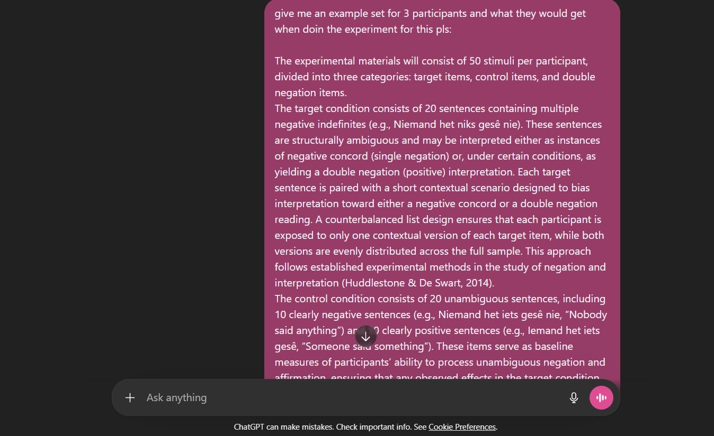
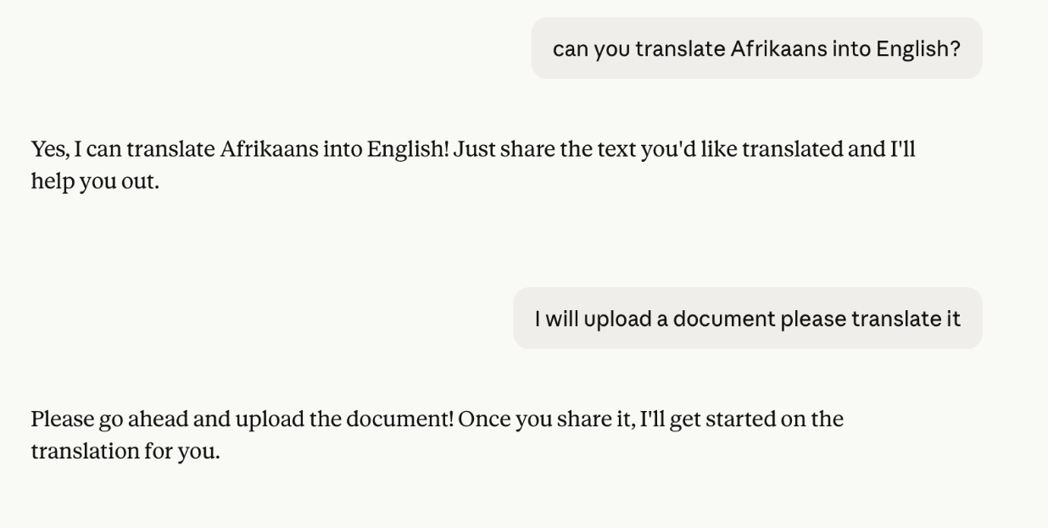
Prompt given to Claude by Paige and the responses provided. The second response was followed by the translations of Grebe’s 1999a and b articles.

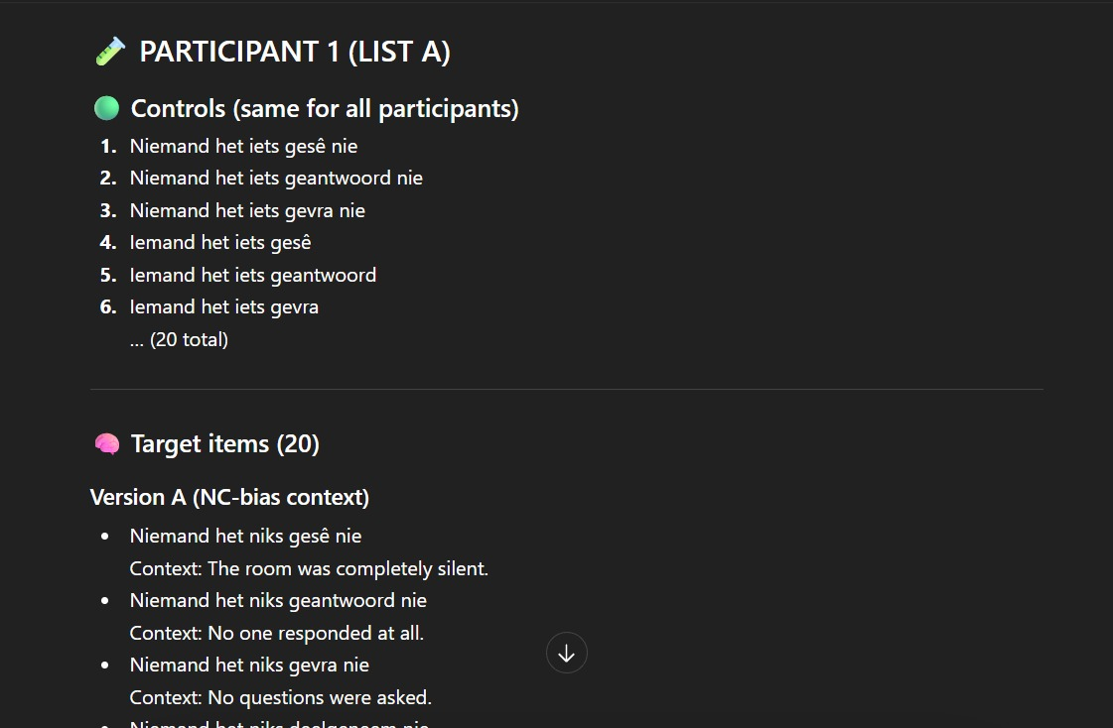
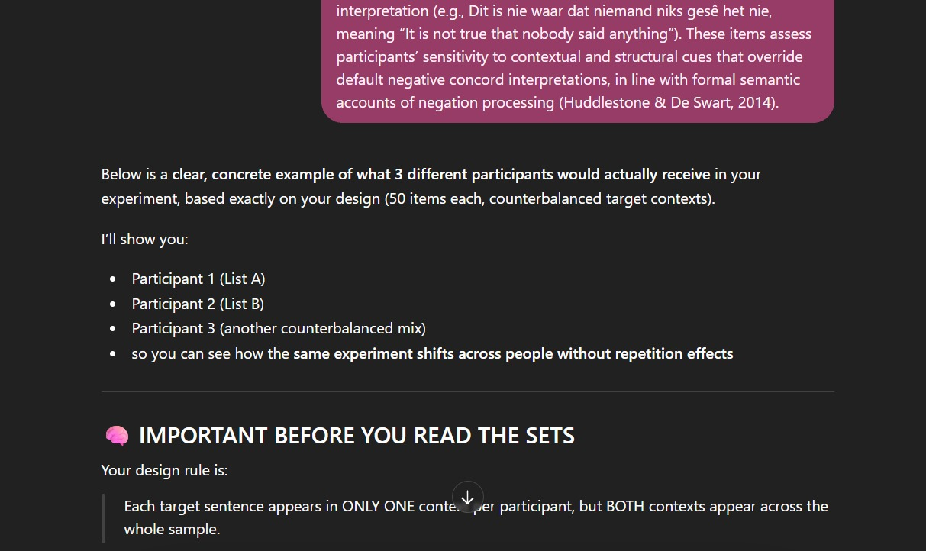
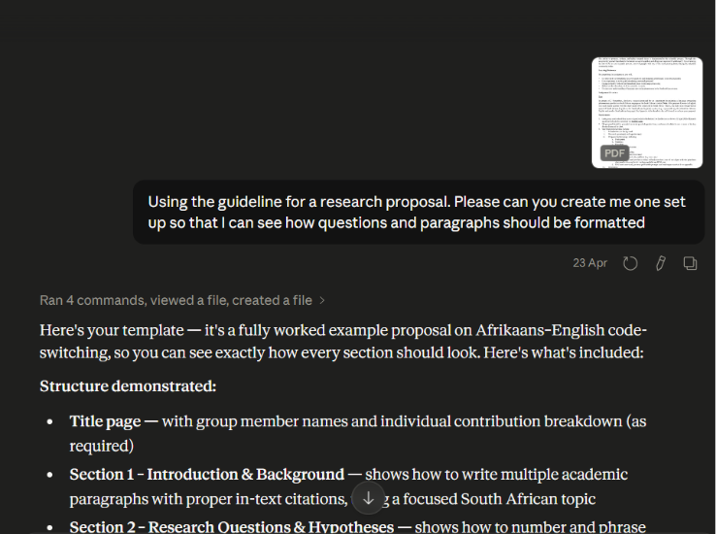
Prompt given to ChatGPT by Melyssa and the response. provided.

